Summary

Adventure through the Claret Grove as Alice, an amnesiac trapped in the dream world, while they try to escape from the eerie forest they awoke in. Use their transformation abilities to discover unknown areas of the grove, and to defend from hungry monsters.

Pillars

Adventure
The player is required to explore the dungeon that they find themselves in. To find the exit they need to find certain key items, and decipher the clues that Chess gives them.

Shape Shifting
This allows for Alice to traverse through the dungeon using each shape’s unique abilities to solve the puzzles that they encounter. They also provide protection for Alice, allowing them to fight back.

Collection
There will be two types of items to collect, consumable items that exist to heal the player’s health/mana/status effect, and key items that will be required to progress in the dungeon.

Demographic

Ashe (17)
Preferred Console: Handhelds (PS Vita, Nintendo 3DS)
Likes: Mystery, Books, Alice in Wonderland
Dislikes: Horror, overly complicated things, reading based tutorials
Background: Often uses games as a way to experience things that would be mostly impossible in reality. Enjoys playing games that allow them to be immersed and play as a character that they can project themselves onto.
User Stories

- As a user, I can control Alice’s movements.
- As a user, I can transform into different creatures.
- As a user, I have different abilities for each creature.
- As a user, I am able to solve puzzles to escape the dungeons I find myself in.
- As a user, I am able to engage monsters in combat.
- As a user, I can pickup items when I enter their radius.
- As a user, I can see what inventory I have.
- As a user, I can heal myself, be it from a status effect or health/mp.
- As a user, I will be able to converse with Chess.
- As a user, I can see my status on screen at all times.
- As a user, I can pause/exit the game.
- As a user, I can alter the settings of the game.
- As a user, I have objectives to complete.

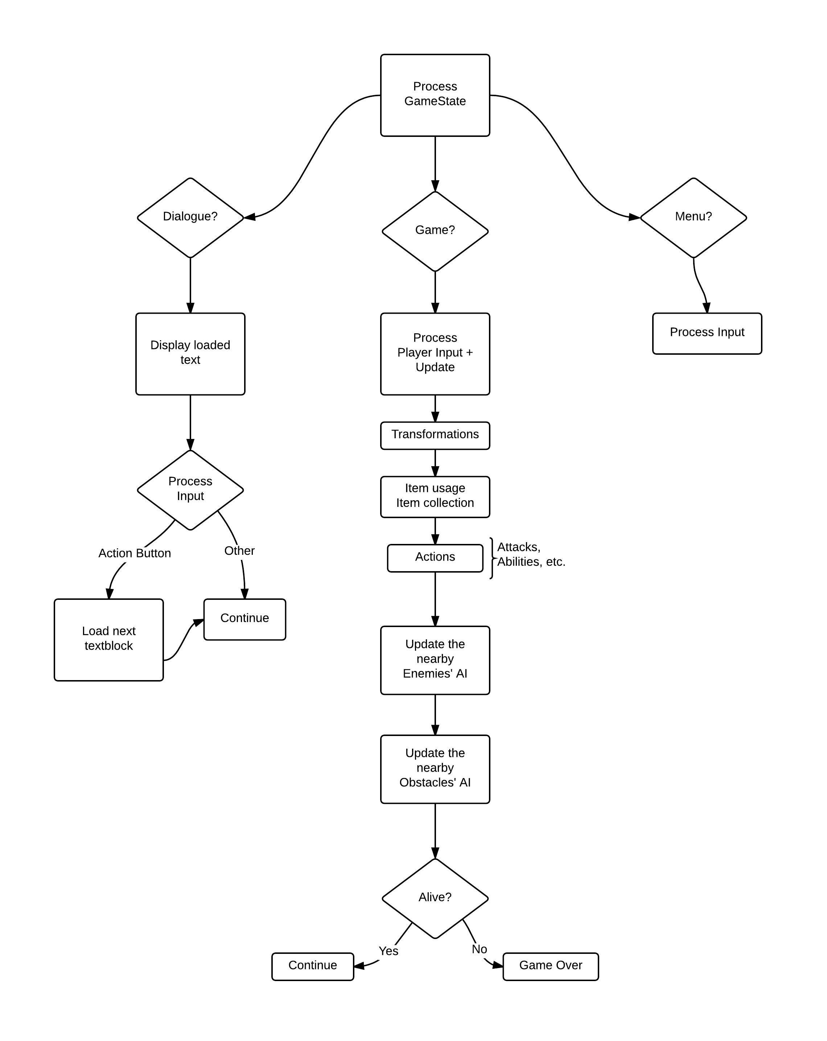
Game Loop

